

# VISVESVARAYA TECHNOLOGICAL UNIVERSITY

## Jnana Sangama, Belgaum-590014

**A DBMS Mini Project Report**

**On**

**“POLICE DATABSE MANAGEMENT SYSTEM”**

**Submitted in Partial fulfillment of the Requirements for the V Semester of the Degree of**

**Bachelor of Engineering In**

**Computer Science & Engineering By**

**SURAJ S**

**(1CE18CS085)**

**Under the Guidance of Mrs. ARCHANA BHAT**

**Asst. Professor, Dept. of CSE**

**CITY ENGINEERING COLLEGE**

**Doddakallasandra, Kanakapura Road, Bengaluru-560061**

**CITY ENGINEERING COLLEGE**



**Doddakallasandra, Kanakapura Road, Bengaluru-560061 DEPARTMENT OF COMPUTER SCIENCE AND ENGINEERING**

**CERTIFICATE**

Certified that the DBMS Mini Project work entitled **“POLICE DATABSE MANAGEMENT SYSTEM”** has been carried out by **SURAJ S (1CE18CS085),** bonafide student of City Engineering College in partial fulfilment for the award of **Bachelor of Engineering in Computer Science and Engineering** of the Visveshvaraya Technological University, Belgaum during the year **2020-2021**. It is certified that all corrections/suggestions indicated for Internal Assessment have been incorporated in the Report deposited in the departmental library. The DBMS Mini Project Report has been approved as it satisfies the academic requirements in respect of project work prescribed for the said Degree.

|  |  |  |
| --- | --- | --- |
| **Mrs.Archana Bhat** | **Mr. B Vivekavardhana Reddy** | **Dr. V. S Rama Murthy** |
| Asst.Prof, Dept.of CSE | Head, Dept. of CSE | Principal |
|  |  |  |
|  | External Viva |  |
| Name of the examiners |  | Signature with date |

1.

2.

**ABSTRACT**

This project includes a summary of system requirements, database design, general definition of the tools and an outline of the means of implementation of a blood donation management system. The objective of this project is the creation of a database management system capable of facilitating the stress-free management and organization of a blood donation database capable of being implemented easily by an NGO. The E-R diagram of the system, analysis/specifications, data flow diagram of the system, database schema with detailed tables, relational mapping, entity and relation descriptions,constraints and scripts of each table are outlined in detail. Subsequently, datasets and screenshots are provided to allow for visualization of the system for the users.

**ACKNOWLEDGEMENT**

While presenting this DBMS Mini Project on “**Police Database Management System”,** I feel that it is my duty to acknowledge the help rendered to me by various persons.

Firstly I thank God for showering his blessings on me. I’m grateful to my institution City Engineering College for providing me a congenial atmosphere to carry out the project successfully.

I would like to express my heartfelt gratitude to **Dr. V S Ramamurthy,**

Principal, CEC, Bangalore, for extending his support**.**

I would also like to express my heartfelt gratitude to **Prof. Vivekavardhana Reddy**, HOD, Computer Science and Engineering whose guidance and support was truly invaluable**.**

I’m very grateful to my guide, **Mrs. Archana Bhat**, Asst. Prof., Department of Computer Science, for her able guidance and valuable advice at every stage of my project which helped me in the successful completion of our project.

I would also have indebted to my Parent and Friends for their continued moral and material support throughout the course of project and helping me in finalize the presentation.

My hearty thanks to all those who have contributed bits, bytes and words to accomplish this Project.

**SURAJ S (1CE18CS085)**

**Table of Contents**

1. introduction………………….……………………………………………………..
2. Requirement specification……………………………..………………………

functional requirements…….………………………………………

Non functional requirements………………………………………

DATA REQUIREMENTS……………………………………………………....

3. Design

ER diagram……………………………………….………………...………..

Schema DIAGRAM…………………………………………………...……...

4. implementation

TABLE CREATION……………………………………………………………..

STORED PROCEDURE………………………………………………………....

INSERTING VALUES FROM FRONT END…………………………………..

CALLING STORED PROCEDURE FROM FRONT END…………………….

5. Snapshots……………………………………………………………………………...

6. conclusion……………………………………………...…………………………….

6. Future enhancement………………………...……………………………………

7. BiBIliography ……………………………………….…...…………………………..

**LIST OF FIGURES**

|  |  |  |  |
| --- | --- | --- | --- |
| **Figure No.** | | **FIGURE NAME** | **Page No.** |
|  |
|  |
|  |
|  |
|  |
|  |
|  |
|  |
|  |
|  |
|  |
|  |
|  |
|  |
|  |
|  |
|  |
|  |
|  |
|  |
|  |
|  |

**INTRODUCTION**

A database management system (DBMS) refers to the technology for creating and managing databases.Basically DBMS is a software tool to organize (create, retrieve, update and manage) data in a database.

The main aim of a DBMS is to supply a way to store up and retrieve database information that is both convenient and efficient. By data, we mean known facts that can be recorded and that have embedded meaning. Normally people use software such as DBASE IV or V, Microsoft ACCESS, or EXCEL to store data in the form of database.

Database systems are meant to handle large collection of information. Management of data involves both defining structures for storage of information and providing mechanisms that can do the manipulation of those stored information. Moreover, the database system must ensure the safety of the information stored, despite system crashes or attempts at unauthorized access.

This project aims at computerizing the manual process of storage system. Front end and backend are implemented using **HTML , MySQL, PHP** and **NODEJS** respectively. Along with the **JSP** program to analyze the program. The project consists of four types of Application forms for **Criminal record, Prisoner record, Police database management, Complaint registration.** It also consists of a **Home Page, Contact us, Login page and Regestration Page**

**The Highlighted Features of The Project includes**

**1.** A good view interface to the users.

**2.** A complaint registration page which can be retrieve for the further .

**3.** A police data storage and retrieve further usage.

**4.** A criminal record database store and retrieve for further usage.

**5.** A Prisoner Data database store and retrieve for further usage.

**6.** A Case Data database store and retrieve for further usage.

**Requirements Specifications**

**Functional Requirements :**

* CREATE POLCE DATA
* CREATE PRISONERS DATA
* CREATE CRIMINAL DATA
* COMPLAINTS DATA
* CASE DATA

**Non-Functional Requirements :**

* **OPERATING SYSTEM :** WINDOWS
* **DATABASE :** SQL
* **DEVELOPMENT TOOLS &**

**PROGRAMMING LAUNGUAGES :** HTML5 , CSS, PHP, SQL , NODE.JS , JAVA ,JS..ETC

* **PROCESSOR :**  DUAL CORE 2.5GHZ
* **MEMORY :**  1 GB
* **HARD DISC :** MINIMUM 80GB HARD DISK

**Data Requirements**

* FOR THE NEW ENTRY OF POLICE DATA
* ID
* NAME
* DSIGNATION
* CASE_NO
* FOR THE NEW ENTRY OF PRISONER DATA
* PRISONER_ID
* PRISONER_NAME
* PRISONER_CASE
* DATE_ARREST
* FOR THE NEW ENTRY OF CRIMINAL DATA
* CRIMINAL_ID
* CRIMINAL_NAME
* CRIME
* DATE_COMMITED
* FOR THE NEW ENTRY OF COMPLAINTS DATA
* COMPLAINT_ID
* COMPLAINT_NAME
* DESCRIPTION
* DATA_REG
* FOR THE NEW ENTRY OF CASE DATA
* CASE_ID
* CASE_NAME
* DESCRIPTION
* DATE_UPDATE

**DESIGN**

**ER Diagram**

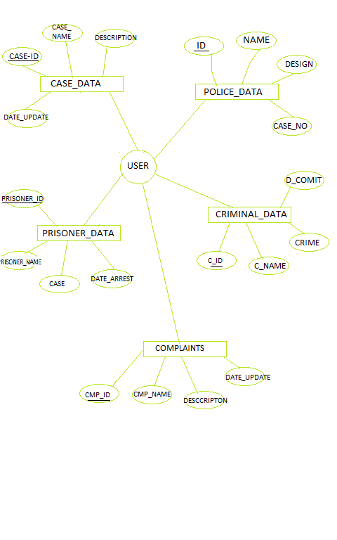

**Schema Diagram**

|  |  |  |  |
| --- | --- | --- | --- |
| **ID** | NAME | DESIGN | CASE_NO |

|  |  |  |  |
| --- | --- | --- | --- |
| **PRISONER_ID** | PRISONER_NAME | PRISONER_CASE | DATE_ARREST |

|  |  |  |  |
| --- | --- | --- | --- |
| **CRIMINAL_ID** | CRIMINAL_NAME | CRIME | DATE_COMMITED |

|  |  |  |  |
| --- | --- | --- | --- |
| **COMPLAINTS_ID** | COMPLAINT_NAME | DESCRIPTION | DATA_REG |

|  |  |  |  |
| --- | --- | --- | --- |
| **CASE_ID** | CASE_NAME | DESCRIPTION | DATE-UPDATE |